Mobile Wireless Health Monitoring: Implementation of a Miniaturized Programmable System-On-A-Chip

Roman Aguilera

**Introduction**

Emerging technical applications require small miniaturized systems with miniature transducers. In the past few decades, applications of transducers have been facilitated by research communities in the areas of communication systems, robotics, and analog data collection. And as technological advancements have progressed, exploration in miniature transducer use for biosensors and wearable electronics for health monitoring and other medical applications has emerged as well, with specific applications ranging from electroencephalographs (EEGs), accelerometers, phonocardiographs, and other types of analog data sensors [1]. Data transmission and microcontroller technologies have advanced synergistically along with sensor technologies, allowing for wireless mobile heath monitoring[2]. With leading industry standards for transferring data through ad-hoc wireless sensor networks, such as Bluetooth® communication, it has become increasingly easier to implement the wireless transfer and synchronization of large data between patient and observer[1]–[3]. Currently, open areas of research that need to be addressed in wireless sensor network technology are (a) user interface, (b) wireless connectivity reliability [1], [4], (c) energy consumption [5]–[7], and (d) size[4]. In this paper we present a novel approach to these bottlenecks by using PSoC® 4 BLE (Programmable System on Chip, Bluetooth® Low Energy), that addresses these bottlenecks in wireless sensor network technologies. Figure A demonstrates a high level scheme of our wireless sensor design using this new device.

**Figure A.** Architecture of our wireless sensor network.

PSoC® 4 will allow us to use the already existing applications of wireless sensor networks along with Bluetooth® Low Energy technology to reduce power consumption. It will also allow us to incorporate the practical use of smart phones as an interface between user and wireless sensor network. The Cypress PSoC® 4 is a new chip that was just introduced in January of 2015.  It is unique in that analog aspects of the system can be programmed, and also that it has analog circuits, a microprocessor, and a full Bluetooth® module all inside of one system[8].  However, given that PSoC® 4 will directly address our bottlenecks of concern, many specific details still need to be addressed including; (i) Making sure all our pieces of hardware (firmware, sensor, and smart phone) in our wireless sensor network are synchronized in communication between each other, and (ii) using programming applications to develop better user interfaces between user and hardware so that we may more seamlessly control our hardware as well as observe our data in real time.

**Methodology**  
**I. Key Aspects That Will Be Developed**

A.) *Programming Firmware of PSOC® 4 Chip for Concrete Applications*

Specifically, many students in Dr. Coleman’s group will develop mobile health applications.  This will be done in close collaboration with graduate student Amr Haj-Omar.  We will learn how to use the op-amps inside the PSoC® 4. We will do this by using the PSoC® 4 software through drag and drop methods.  With the op amps, we will Implementing some basic amplifier circuits.  Programming the system to use op-amps in different stages, in software, provides incredible flexibility but inside a small chip that is miniaturized and portable.  We will research the different power settings that PSoC 4 allows us to use.  Contingent upon time availability, we will also explore implementing analog-to-digital (A/D) converters of different resolution.  Higher resolution means higher precision. But on the other hand it also means more bits to process, and thus more energy.  We will explore changing these settings in the firmware that we will develop, thus once again resulting in agile solutions for different applications with varying resolution versus energy requirements.

B.) *Interfacing the Firmware Programming with Software Applications for Smart Phones*

This will be done in close collaboration with Ph.D. student Justin Tantiongloc.  With Justin, we will learn how to program the PSoC® 4 Bluetooth® system. We will also explore adjusting the Bluetooth® system's settings. There are a couple of applications in Dr. Coleman’s group that require different transmission rates and energy usage.  We will research these settings and develop a setting for each application: one at low energy and low bit rate.  Another at higher energy, higher bit rate.  Having the ability to do this in software, which we will develop, will greatly improve the research group’s ability to rapidly deploy solutions for health monitoring and other applications.

II. **Specific Applications to be Enabled**

A.) *Wireless Step Motor*

We will create a solution with the PSoC® 4 to wirelessly control a motor for implanting electrodes at different layers in the brain.  This is for an application with post-doctorate Marcelo Aguilar Rivera who controls the depths of electrode arrays in the brain, with a small motor.  Right now this is done manually . However, with the PSoC® 4 and a smart phone application, this can be done by simply controlling a smart phone.  This application has a larger battery which requires precision more so than low energy.

B.) *Wireless Mobile Health Monitoring Applications*

Dr. Coleman’s group develops a variety of mobile health monitoring applications for collaborations with clinicians. Using the Bluetooth® system, with its re-programmable analog parts, allows for rapid monitoring of a variety of health conditions such as EEG, EKG, and respiration.  Because of expected frequent human use, it is necessary for the system to be small and portable. Thus, we will focus on minimizing both energy consumption and bit rates.  However, the bit rates cannot be too small because the signal still needs to remain reliable for the clinician to derive a proper diagnosis.

1) Flexible Respiration Sensor for Monitoring of Sleep Apnea Patients

Sleep apnea is a disorder where a patient is unable to breath during sleep, often for a minute or longer. Sleep apnea affects more than 18 million Americans of all ages which can cause high blood pressure, memory problems, weight gain, and headaches as well as other health complications. Fortunately, sleep apnea is treatable but It is estimated that about 10 million Americans with this disorder are undiagnosed[9].

We want to develop a noninvasive system to: (i)wirelessly monitor a patient’s apnetic episodes and (ii)develop useful statistical information that can assist physicians in their diagnosis of sleep apnea. The PSoC® 4 allows us to use achieve these objectives. We hope to partner with the Cypress Semiconductor Corporation, the creator of PSoC® 4, to build a miniature chip to incorporate into our bandage-like respiration sensor that will be placed on the patient's chest. This sensor will detect a patient's respiration patterns during sleep and send them to a device via Bluetooth® Low Energy

Part of Dr. Coleman's lab specializes in the fabrication of flexible epidermal electronics[10]. Graduate students Dae Kang and Yun Soung Kim are working on fabricating a flexible strain gauge resistor that has a greater resistance when stretched. This strain gauge will be integrated into our sensor, along within our miniature chip fabricated by Cypress. In the end, we will have a sensor that we will place on a patient's chest that will measure the respiration rates of the patient during sleep.

a) Preliminary Design of Respiration Sensor

Our first design of the sensor, as seen in Figure B, is a three stage circuit: the first stage is Wheatstone Bridge with the variable resistance being our strain gauge, the second stage is a comparator circuit (and simultaneously an amplifier circuit) that uses an operational amplifier on the PSoC® 4 which also works as an Amplifier circuit, and the third stage is another amplifier circuit that feeds the final output voltage to a light emitting diode (LED). The final design will not have an LED, but we will use an LED in our preliminary designs as visual representation of an output signal. This will let us know if our circuit is functioning correctly and outputting a voltage when we expect it to.

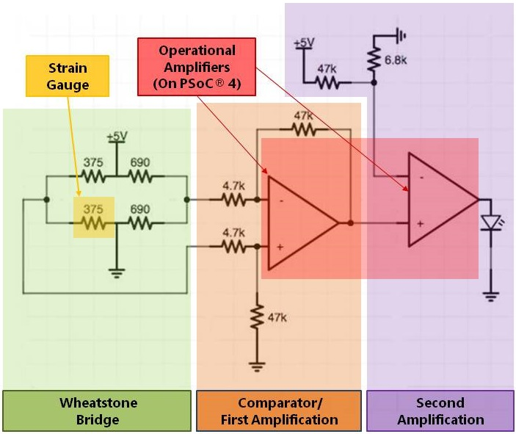

**Figure B.** The circuit is a preliminary design of our respiration sensor. The sensor is divided into three stages of operation: (i) the Wheatstone bridge, (ii) the first amplification stage, (ii) the second amplification stage.

b) Comparison of Operational Amplifiers: PSoC® 4 and Texas Instruments TI-μa741

To observe the functionality of the operational amplifiers found inside the PSoC® 4, we drew a comparison to a control group of Texas Instruments TI-μa741 operational amplifiers, a standard operational amplifier used in many university electrical engineering lab courses. We use the TI-μa741 operational amplifier to design a simple amplifier circuit with a gain of -2. A general design of the amplifier circuit we implemented for this comparison circuit is seen in figure C.

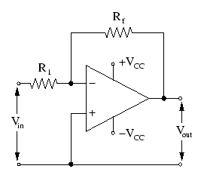Gain of simple circuit.gif

**Figure C.** Design of simple amplifier circuit. This design was used to compare the PSoC® 4 operational amplifiers with the TI-μa741 operational amplifiers.

We chose Rf to be 20 kilo ohms and Ri to be 10 ohms, giving the simple amplifier design a total gain of -2. Using the TI-μa741 operational amplifiers, we build two of these amplifier circuits side by side on a bread board, powered by a 5 Volt source. We build two of the same circuit as a check to ensure that we have a functional control group to draw our comparison from. Analog Discovery™ ( a device made by Digilent) along with Waveforms™ (Analog Discovery's™ auxiliary software), can feed various types of input voltage signals to circuits and measure output voltage signals of circuits. We use this device to power our circuit and to test how the circuit responds to various different input waveforms. After feeding various sinusoidal voltage waves into the input and measure the response output, we see that each amplifying circuit is amplifying the input voltage by a factor of -2, as we expect it to. We observe that the output voltages for the TI-μa741 operational amplifiers cut off at 4.2V Volts and -3V. Because the operational amplifier in this circuit was powered by 5V and -5V voltage source, it would not be possible for both the TI-μa741 operational amplifier and the overall amplifier circuit to output a voltage that is greater than 5V or less than -5V. Figure D shows some recorded waveforms demonstrating these observations.

(i) Input Voltage ±1V at 20kHz (ii)Input Voltage ±3V at 20kHz

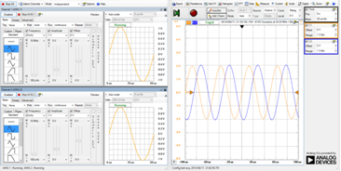 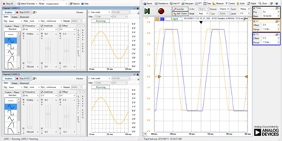

**Figure D.** (i)The left mage shows the TI-μa741 operational amplifiers' response to a sinusoidal input voltage of ±1V at 20kHz which was input to our simple amplifier circuit. The output is an amplified voltage wave of ±2V at 20kHz. (ii)The right image shows the TI-μa741 operational amplifiers' response to a sinusoidal input voltage of ±3V at 20kHz. The output is an amplified voltage with cut off voltages at 4.2V and -3V.

Before we could draw a comparison between the TI-μa741 operational amplifier and the PSoC® 4 operational amplifiers, we first had to program the PSoC® 4 to a mode that implements its operational amplifiers. We use the PSoC® Creator™ 3.1 integrated design environment (IDE ) software to achieve this by creating a project. Figure E shows the project's design schematic that we implemented inside the IDE.

Machine generated alternative text:
Respiration Sensor
PWR_2
T
HI
r vMv —+- — —ðW—-i m_7
, 371 leO RI —
. I.. vv%’? 47( .
, I 47k
I H) R4 p
• 375
ims 
47K e
pwqt
Ri
I- +
47k
k5
Ves

**Figure E.** Top design for implementing two operational amplifier on the PSoC® 4.

We then went inside C code of the of the project and wrote the following code:

#include <device.h>

void main()

{

/\* Start components\*/

Opamp\_Start();

Opamp\_1\_Start();

/\* Sets Opamp power mode to High power \*/

Opamp\_SetPower(Opamp\_HIGH\_POWER);

Opamp\_1\_SetPower(Opamp\_HIGH\_POWER);

}

The Opamp\_Start(); function performs all required initializations and powers on the operational amplifier block within the PSoC® 4. The Opamp\_SetPower(); function sets the drive power of the operational amplifier block to either LOWPOWER, MEDPOWER, or HIGHPOWER. For this application, we set it to HIGHPOWER mode.

After editing the code, we went to the pin assignments settings, to decide which pins we wanted to use on the PSoC® 4. The pin assignment setting also lets us rearrange the pins to be assigned as the nodes of the operational amplifier. We noted that the input pins of both operational amplifiers on the PSoC® 4 were able to be rearranged within themselves. However, the output pins had dedicated pins on the PSoC® 4, meaning that those pins could not be rearranged. Figure F shows how we assigned our pins.

Machine generated alternative text:
Alias 
Opa. I_ne g_lnput 
Opa. 
Opa. 1 _po s_lnpu t 
Opa. 2 _ ne g _ Input 
Opa. 2 _po s_lnput 
Tcpwo:line out _conpl, 
Lpcoyp:complll, 
out, 
scB1•.spi 
sczo:spl 
OA3:vm1nus, 
scEo:i2c 'da, 
scBo:sp1 
OA3:vpLus, 
Cx, scEo:i2c sci, 
SCBO: 
aaaaaaaa• 
CY8C4247LQ1-3L483 
56-QFN 
aaaa 

**Figure F.** PSoC® 4 pin assignments for the newest design of the respiration sensor. These pin assignments allow use the PSoC® 4's operational amplifiers.

Now that our PSoC® 4's operational amplifiers were ready to use, we then took the originally built simple amplifiers circuits (see Figure C) and switched the TI-μa741 operational amplifiers with the operational amplifiers that we enabled in the PSoC® 4. What we found was that the circuit with the PSoC® 4 operational amplifiers amplified the signal at the same amount as the amplified the μa741 operational amplifiers. However, we observed that the circuit with the PSoC® 4 operational amplifiers had an upper cut off voltage of 3.2 Volts and a lower cut off voltage of 0 Volts. Because the operational amplifier in this circuit was powered by only a 3.3V voltage source and no negative voltage source (as opposed to ±5V voltage sources in the previous case), it would not be possible for both the PSoC® 4 operational amplifiers and the overall amplifier circuit to output a voltage that is greater than 3.3V or less than 0V. Figure G shows some recorded waveforms that demonstrate these observations.

(i) Input Voltage ±1V at 20kHz (ii) Input Voltage 2±1V at 20kHz  
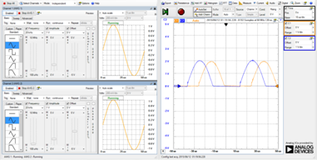 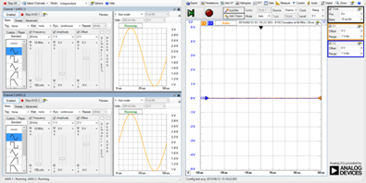

(iii) Input Voltage -1±1V at 20kHz (iv) Input Voltage -1±1.2V at 5Hz  
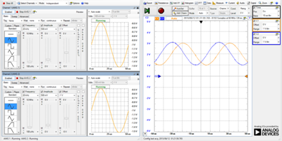 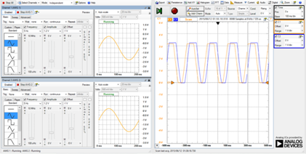

**Figure G. (i)** The top left image shows the PSoC® 4's operational amplifiers' response to a sinusoidal input voltage of ±1V at 20kHz which was input to our simple amplifier circuit. The output is an amplified voltage wave of ±2V at 20kHz with a lower cutoff voltage at 0V**. (ii)** The top right image shows a the PSoC® 4's operational amplifiers' response to a sinusoidal input voltage of 2±1V at 20kHz. The output is a voltage wave at a constant 0V**. (iii)** The bottom left image shows the PSoC® 4's operational amplifiers' response to a sinusoidal input voltage of -1±1V at 20kHz. The output is a sinusoidal voltage of 2±2V at 20kHz**. (iv)** The bottom right image shows the PSoC® 4's operational amplifiers' response to a sinusoidal input voltage of -1±1.2V at 20kHz. The output is a sinusoidal voltage of 2±2.4V at 20kHz with cut off voltages at 3.2V and 0V.

So in sum, we know that the PSoC® 4's operational amplifiers can perform amplifications equal to that of a standard Texas Instruments TI-μa741 operational amplifier. However, the PSoC® 4's operational amplifiers cannot output voltages greater than 3.2 V or less than 0V.

b) Building Preliminary Design of Respiration Sensor

Using the Texas Instruments TI-μa741 operational amplifiers, we assembled the circuit from the design in Figure B. We simulated the strain gauge with a potentiometer. Ideally the LED at the end of the circuit should have been turned on when our potentiometer had a resistance greater than 375 Ohms. However, the LED turned on when our potentiometer passed about 475 0hms. This was not a problem because our strain gauge circuit ranges between 215 to 222 Ohms, so we could increase the resistance of the strain gauge with extra resistors in order to make our circuit function. Afterwards, we replaced the TI-μa741 operational amplifiers with the PSoC® 4's operational amplifiers. We found that the circuit with PSoC® 4's operational amplifiers worked just as well as the circuit with the TI-μa741 operational amplifiers. We were able to successfully implement our preliminary design with the PSoC® 4's operational amplifiers.

 c) Implementing Analog-to-Digital Convertor in Preliminary Design of Respiration Sensor

Our end goal for this respiration sensor is to be able to obtain meaningful information to diagnose patients with sleep apnea. However, the design that implements two operational amplifiers (shown in figure E) works as only a binary circuit that will indicate when a threshold chest position is exceeded. We must then include in our design a digital-to-analog convertor in order to precisely record small changes in voltages. We thus replace the second amplification stage in figure B with digital to analog converter.

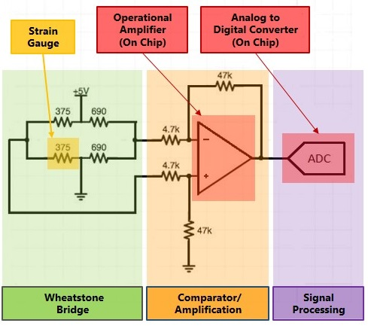

**Figure H.** This is a modified and improved circuit of the respiration sensor. This new design uses an analog-to-digital converter (ADC). The third stage is replaces the second amplification with a signal processing stage.

The output of the second stage (Comparator/Amplification Stage) is fed into the third stage (Signal Processing Stage). The ADC gives us more flexibility as to how our circuit works. We can modify firmware coding and change the ADC functionality at ease within the PSoC’s integrated development environment (IDE). The PSoC IDE uses C programming language to program firmware. After integrating the ADC we are now able to collect more subtle changes in chest movement.

d) Integrating PSoC Bluetooth Low Energy Transceiver

Now that we are able to record subtle changes in chest movement, we must now take the output signal from our respiration sensor and transmit it via Bluetooth Low Energy. We do this by implementing the Universal Asynchronous Receiver Transmitter (UART) within the PSoC 4 (See figure I). The PSoC 4 IDE allows us to use this UART through drag and drop methods. We are also able to easily change specific receiving and transmission settings depending on the functionality of our sensor design.

e) Communication Between Sensor and Mobile Device

Our last step is to develop the connection protocol (GAP) and communication (GATT) protocol between our sensor and mobile devices. Using the PSoC IDE, we configured both GAP and GATT settings in a Bluetooth Low Energy profile for our sensor.

Machine generated alternative text:
Respiration Sensor
PWR3
PWR_2
R4 T R.3
r _AAV_+_vVV_, R_9
10K ‘
, ,
R_5
10k
Button s used to wake device up WDT
from low power hibernate mode Qibi Si el
SW2
SW2
Wakeup_Interrupt tWDT_lnterrupt
VÓd
R.d $ T Red LED Is used to indicate
onnect SLED /V\’ - — f4-- — - ¿ that device is in disconnected state.
I
_______ Green LED is used to indicate
-+ that device is advertising.
Biu  I
__,joPower_LED •-v%,V-— - ¡4 -‘ Blue LED is used to indicate
Low battery level (<10%).
f5Oit 
¿o
Vss
ir
I 10k R7 10k I
I - I I  I
I . 65
I I 10K ‘
I I RiO I
: Vss , : :
I I , 10k I
: : : : L y.i2us_2
L  
Vss
UART s used fo transmitting
the debug information
UAR T_DE B
BLE component configured as Health
Thermometer profile with Battery service
BLE
BLE
O Blueto

**Figure I.** Updated circuit design for respiration sensor within the PSoC4 IDE. This final design uses an operational amplifier, analog-to-digital converter (ADC), and a UART. A BLE profile is also configured to determine how our sensor will communicate with other devices.

Machine generated alternative text:
3O
ez’ E
PZZE
P2I
P2t1J
VOAE
eim .
.i E
PILZ 31
1ij Z9
VC&1
Vc.2
:  CP4.
aafr_. æa.a_a
‘.
.AT_CI 
CMw• *4
a:
:s& CW 
aa
: :
g g
tít’
¡ • A 
‘? 4 1 ¡
j. 
a. j
wpr 
>>
Ivc
XTA.32W
S ‘4(02
S
7 #5(01
I •5(l
v”0
Iv
:_,•4 
a:  a:. .._
:-.r_.— 
a:
, .
a:I  a:
:  1,  
KI #
30.
CY8C4247LQ1-BL483
56-OF N
13
v:c
= ,
, ). w > . . . . , . . . . .
(
)

**Figure K.** PSoC® 4 pin assignments for the newest design of the respiration sensor. These pin assignments allow use the PSoC® 4's operational amplifiers, analog-to-digital converters, UART as well as other components within the PSoC® 4.

2) Miniature Flexible Electroencephalograph Sensor

Dr. Coleman's Lab has also researched applications in using wireless flexible electronics to develop sensors (e.g. Electroencephalograms (EEG), electrocardiograms (ECG), electromyographs (EMG)) and implementing them studying patient electrical signals throughout different parts of the body. We plan to design a sensor using PSoC® 4 and with the help of Cypress Semiconductor Corporation, we will fabricate a wireless flexible EEG chip at a much lower cost than current applications in the Coleman lab.

**Results**

The analog components found in PSoC® 4 were enabled through software tools. These analog components' performance were compared to standard analog components (see Figure D and Figure G). The user interface flexibility for our application was also investigated (see Figure F). The PSoC® 4's analog electrical components capabilities were used to create a preliminary design for a respiration sensor.

**Discussion**

The key aspects being addressed in this application of new technology are energy consumption, portability, and wireless communication. Looking at the built preliminary design for a respiration sensor, further development is needed. A new design must integrate the use of an analog-to-digital converter (ADC) for signal conversion to data. This data would be susceptible to analysis and signal processing methods using various software tools. Furthermore, a newer design with an implemented ADC must also run at optimal power levels so as to increase the battery life of the overall sensor. Nevertheless, Sampling rate of data must be adequately high enough for specific applications of sensors. A new design must also take into account the use of a UART to transmit and receive data.

**Conclusion**

An new Bluetooth Low Energy microcontroller technology , the PSoC® 4, was implemented to address various wireless mobile health applications in the Coleman Lab, namely the development of a wireless respiration sensor for patients with sleep apnea. The use of analog components in this new technology allows us to create a variety of mobile wireless health sensors. Advancements were made towards finding a low cost solution to monitor the respiration patterns of patients suffering sleep apnea

References

[1] A. Pantelopoulos and N. G. Bourbakis, “A survey on wearable sensor-based systems for health monitoring and prognosis,” *IEEE Trans. Syst. Man Cybern. Part C Appl. Rev.*, vol. 40, no. 1, pp. 1–12, 2010.

[2] Y.-G. Lee, W. S. Jeong, and G. Yoon, “Smartphone-Based Mobile Health Monitoring,” *Telemed. e-Health*, vol. 18, no. 8, pp. 585–590, 2012.

[3] E. Vergetis, R. a Guérin, S. Member, R. Guérin, and S. Sarkar, “Can Bluetooth Succeed as a Large-Scale Ad Hoc Networking Technology ?,” vol. 23, no. 3, pp. 644–656, 2005.

[4] M. A. Mahmood, W. K. G. Seah, and I. Welch, “Reliability in wireless sensor networks: A survey and challenges ahead,” *Comput. Networks*, vol. 79, pp. 166–187, 2015.

[5] I. F. Akyildiz, W. Su, Y. Sankarasubramaniam, and E. Cayirci, “A survey on sensor networks,” *IEEE Commun. Mag.*, vol. 40, no. 8, pp. 102–105, 2002.

[6] M. a. M. Vieira, C. N. . J. Coelho, D. C. . J. Da Silva, and J. M. Da Mata, “Survey on wireless sensor network devices,” *EFTA 2003. 2003 IEEE Conf. Emerg. Technol. Fact. Autom. Proc. (Cat. No.03TH8696)*, vol. 1, 2003.

[7] L. Negri, J. Beutel, and M. Dyer, “The power consumption of bluetooth scatternets,” *2006 3rd IEEE Consum. Commun. Netw. Conf. CCNC 2006*, vol. 1, pp. 519–523, 2006.

[8] “PSoC® 4 Bluetooth® Low Energy Product Overview.”

[9] American Sleep Apnea Association, “Children’s Sleep Apnea,” 2015. [Online]. Available: http://www.sleepapnea.org/treat/childrens-sleep-apnea.html. [Accessed: 22-May-2015].

[10] D.-H. Kim, N. Lu, R. Ma, Y.-S. Kim, R.-H. Kim, S. Wang, J. Wu, S. M. Won, H. Tao, A. Islam, K. J. Yu, T. Kim, R. Chowdhury, M. Ying, L. Xu, M. Li, H.-J. Chung, H. Keum, M. McCormick, P. Liu, Y.-W. Zhang, F. G. Omenetto, Y. Huang, T. Coleman, and J. A. Rogers, “Epidermal Electronics,” *Science (80-. ).*, vol. 333, no. September, pp. 838–844, 2011.